EREZER
Admin Panel
A simple guide for shop staff
No technical knowledge needed. Each task is written as short steps you can follow while looking at the screen.
Version 3 · October 2026

What is in this guide
Part | Topic | Use it when you want to…
1 | Getting started | Log in and find your way around
2 | Your daily routine | Know what to check every day
3 | Orders | See new orders, move them forward, print an invoice
4 | Products | Add, change or remove products and photos; fits, sizes and colours; many products at once; which products come first in the shop
5 | Categories and subcategories | Organise products into groups
6 | Inventory (stock) | Update how many pieces you have
7 | Offers and prices | Run a sale, a promo code, a flash sale or a bundle
8 | Shipping | Set delivery prices and free shipping
9 | How the shop looks | Change banners, the home page, shop information, size charts and the shop's own pages
10 | Customers and messages | Handle returns, custom designs and reviews; answer customer messages
11 | Sales numbers | See how the shop is doing
12 | Staff | Add a staff member and control what they can do
13 | Problems and answers | Fix the most common problems yourself
14 | Quick finder | Find the right page for any task in one table

1. Getting started
The admin panel is the private side of the Erezer shop. Customers never see it. Everything you do here changes what customers see in the shop: products, prices, stock, banners and offers.

Logging in
- Open the admin panel address that the shop owner gave you, in Chrome on a laptop or computer.
- Type your username and password, then press Sign In.
- You arrive on the Dashboard.
Remember Each staff member has their own login. Do not share yours: the panel keeps a record of who changed what (see Activity log in Part 12).

Finding your way around
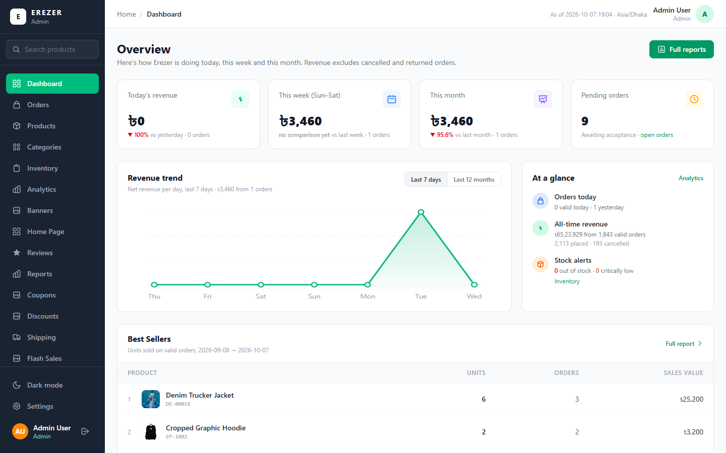
Picture: The Dashboard. The dark menu on the left is on every page.
The dark menu on the left is how you move around. Click a name to open that page. If you do not see a page that this guide mentions, your login has not been given permission for it; ask the shop owner.
Menu item | What it is for
Dashboard | Today's sales and what needs attention
Orders | Every customer order
Products | The list of everything you sell
Shop Order | Which products come first on the Shop page and the category pages
Categories | Groups of products, such as Hoodies or T-Shirts
Inventory | How many pieces of each product are in stock
Banners, Home Page | The pictures and sections on the shop's home page
Size Charts, Pages | The size tables shown on product pages; the shop's own pages, such as Our Mission and Shipping & Returns
Coupons, Discounts, Flash Sales, Bundles | Offers and price reductions
Shipping | Delivery prices
Returns, Custom Orders, Support, Reviews | Things customers send you
Analytics, Reports | Sales numbers
Customers, Newsletter | Who buys from you and who signed up for emails
Settings | Shop information: policies, contact, payment methods, footer
Staff, Activity log | Staff logins and the record of changes

Five things that work the same on every page
- Nothing is saved until you press the save button. It is usually blue and says Save, Update or Confirm. If you leave the page first, your typing is lost.
- A green message in the bottom corner means it worked. A red message means it did not; read it, it says what to fix.
- Before anything is deleted, the panel asks "are you sure?" Read the question before pressing Yes.
- Search boxes at the top of lists find things by name or code. Type a few letters and wait a moment.
- Long lists come in pages. Use Previous and Next at the bottom of the list.
Tip You can switch between a light and a dark screen with Dark mode at the bottom of the menu. The pictures in this guide use the light screen.

2. Your daily routine
If you only have ten minutes, do these in order. Each one is explained later in the guide.
 | Check | What to do
1 | Dashboard | Look at "Pending orders" and "Stock alerts".
2 | Orders | Open each new order (status PLACED) and accept it. Move packed and sent orders forward.
3 | Inventory | Restock anything shown as Low Stock or Out of Stock.
4 | Custom Orders | Answer new custom design requests.
5 | Returns and Support | Answer return requests and customer messages.

3. Orders
The Orders page lists every order. The four boxes at the top show the totals: all orders, pending, out for delivery, and completed.
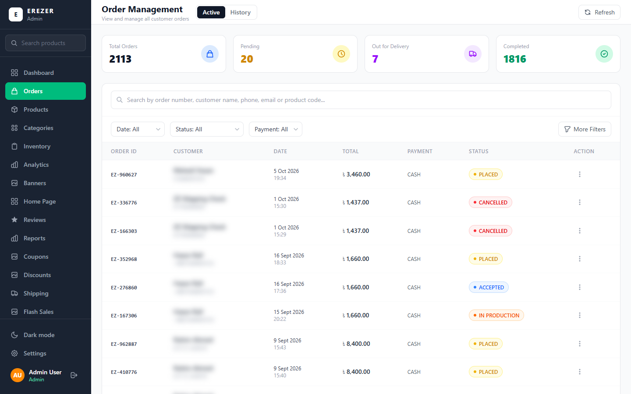
Picture: The Orders page. Customer names are hidden in this picture.

Finding an order
- Type the order number (for example EZ-960627), the customer's name, phone or email, or a product code in the search box.
- Use the three boxes under the search to narrow the list: Date, Status and Payment.
- Active shows orders still being handled. History shows finished ones.
- Press Refresh to load any orders that came in while the page was open.

What each status means
An order moves through these steps, from top to bottom. The customer can see the current step when they track their order.
Status | Meaning
PLACED | New. The customer has ordered and is waiting for you.
ACCEPTED | You have confirmed you will fulfil it.
IN PRODUCTION | The item is being made or printed.
PROCESSING | The order is being packed.
SHIPPED | It has left the shop.
OUT FOR DELIVERY | The courier is bringing it to the customer.
DELIVERED | The customer has it. The order is complete.
CANCELLED | The order was stopped. Its stock goes back automatically.
RETURNED | The customer sent it back.

Opening an order and moving it forward
- Click the order in the list. Its details page opens.
- Check the items, the customer information and the delivery address. Each item shows the colour, fit and size the customer chose, with the picture of that colour.
- On the right, find Update Status.
- Open Next status and choose the next step (for a new order: Accepted).
- If you want, type a short note to the customer.
- Press Update status.
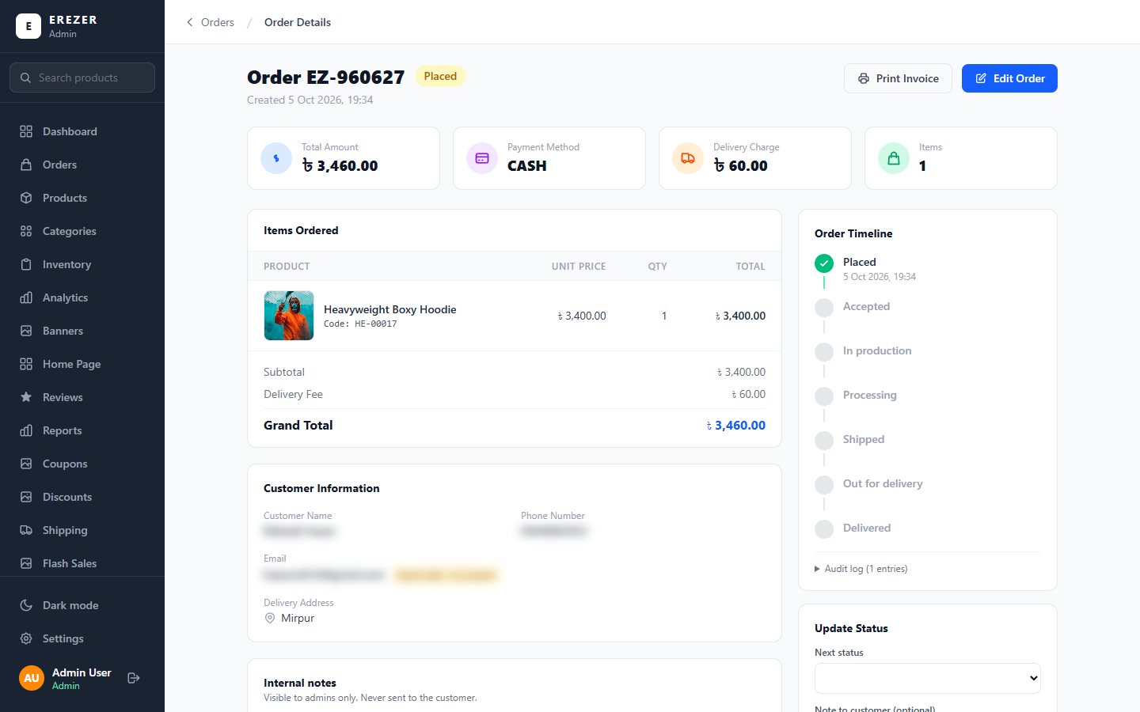
Picture: An order's details. The timeline on the right shows how far it has gone.
Remember You can only move an order to the steps offered in the "Next status" box. This stops an order from skipping a step by mistake.
Once an order is Delivered, Next status shows No change (Delivered). The only step left is Returned: choose it only when the customer has sent the order back.

Other things you can do on an order
- Print Invoice opens the invoice for printing, to put in the parcel.
- Edit Order lets you correct the order's details.
- Internal notes are for staff only. The customer never sees them. Use them to tell your colleagues something, such as "customer asked to deliver after 5 pm".
- The emails the customer receives (order confirmed, and one for each new status) are sent by the shop itself. The confirmation names the colour, fit and size of each item.
- To cancel, choose Cancelled in Next status. The stock of the items is returned to the shop automatically.
Be careful Cancelling cannot be undone. Check with the customer before you cancel.

4. Products
The Products page lists everything you sell. Each row shows the picture, name, code, category, price, delivery charge and stock.
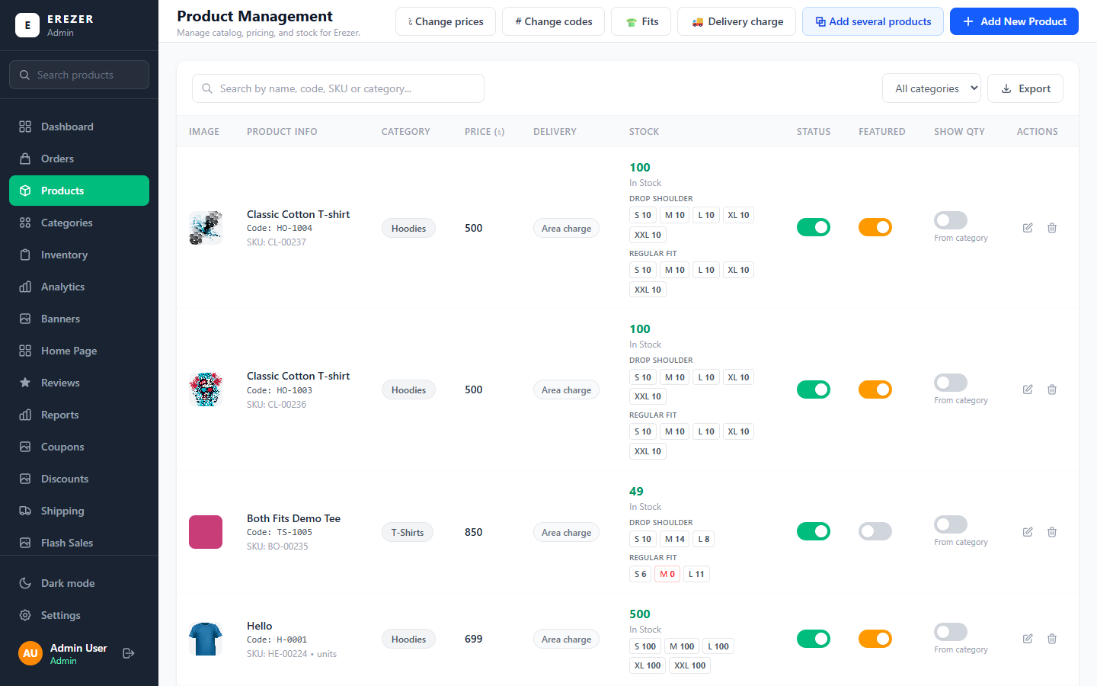
Picture: The Products page.

Reading a product row
- The tick box at the start of a row selects the product, so you can change many products at once (see "Changing many products at once").
- Code is your own product code, such as HO-1002. It appears on invoices.
- Stock is how many pieces you have. For a product sold in sizes, the big number is the total and the small boxes under it show each size: S 600, M 600 and so on. For a product that comes in fits, the sizes are listed under each fit: DROP SHOULDER, then REGULAR FIT.
- For a product that comes in colours, the sizes are listed under each colour, and under each fit of that colour.
- Status switch: green means customers can see and buy it. Switch it off to hide the product without deleting it.
- Featured switch: orange means it shows in "Featured products" on the home page.
- Show Qty switch: on means the product page shows the real number ("12 in stock"); off means it shows a label (In stock / Only a few left / Out of stock).
- The pencil opens the product to edit it. The bin deletes it.
Tip To take a product off the shop for a while, switch Status off. Only delete a product you will never sell again.

Adding one product
- On the Products page, press Add New Product.
- Type the Product Name and a Description. The description can be up to 2000 characters. You can write it as a list, one point per line, with symbols such as 📌 or •; each line shows as its own line in the shop.
- Product Code: when you choose the category, the panel suggests the next free code. You can keep it or type your own.
- Pictures: drop the photos into the box, or click it to choose them. The first picture is the main one shown in the shop. You can add up to 10.
- Options (only if the product comes in colours or another choice): press + Colour. This is explained in "Colours and other options" below.
- Fit and sizes: tick the fits, then the sizes of each fit and their stock. This is explained in the next section.
- Base Price: type the normal price.
- Discount (optional): choose % for a percentage or ৳ for a fixed amount, and type the number. The line under it shows what customers will pay.
- Choose the Category.
- Size chart (optional): choose the size table this product shows. Leave it as it is to use the chart of its category, or the shop's default chart (see Part 9).
- Tick any of the options you want (see the table below).
- Press the save button. The product, its pictures and its sizes are all saved together.
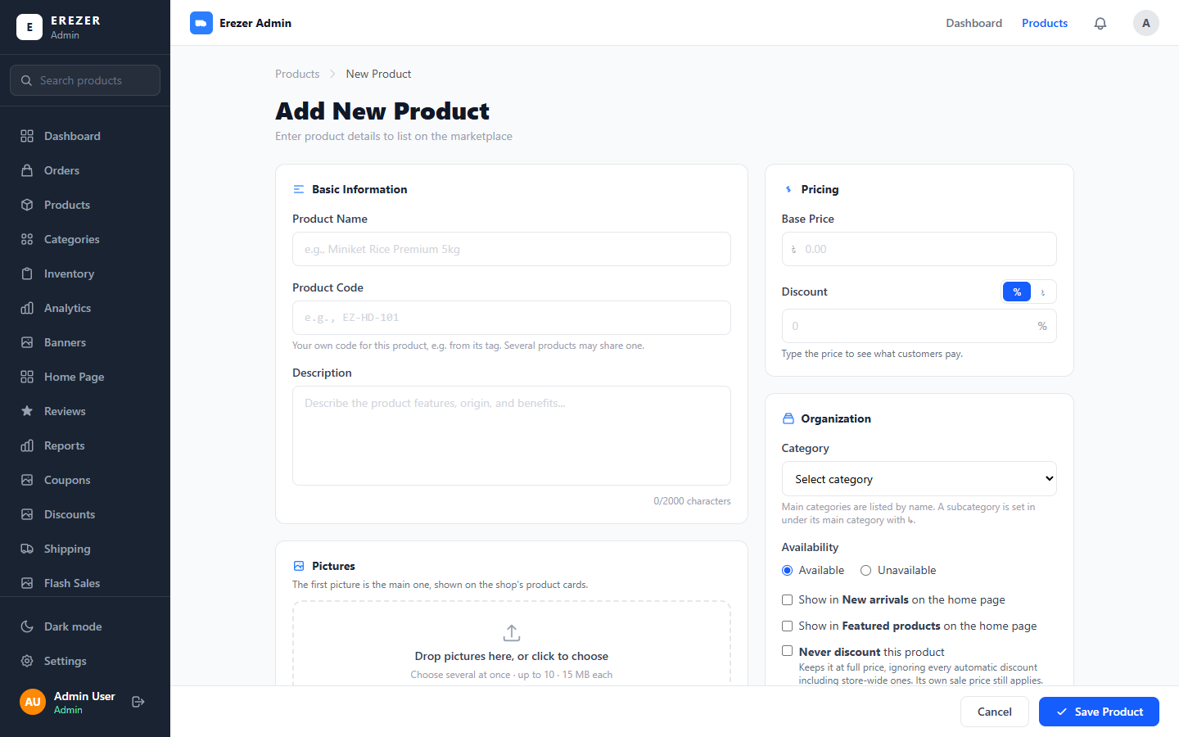
Picture: The Add New Product page.
Option | What it does
Available / Unavailable | Available puts it on sale straight away.
Show in New arrivals | Shows it in the "New arrivals" section of the home page.
Show in Featured products | Shows it in the "Featured products" section of the home page.
Never discount this product | Keeps it at full price during automatic discounts (the Discounts page). Its own Discount above still applies.
Stock on the product page | Same as category, Show quantity, or Show labels.

Remember Photos are stored exactly as you upload them; the shop does not shrink or change them. The shop shows the whole photo. For product cards to look their best, use photos that are all the same shape: tall (portrait) photos work best.

Fit and sizes: Drop Shoulder and Regular Fit
A product can come in Drop Shoulder, in Regular Fit, in both, or in neither. In the shop the customer picks the fit first and then the size. Each fit has its own sizes, its own stock and, if you want, its own price.
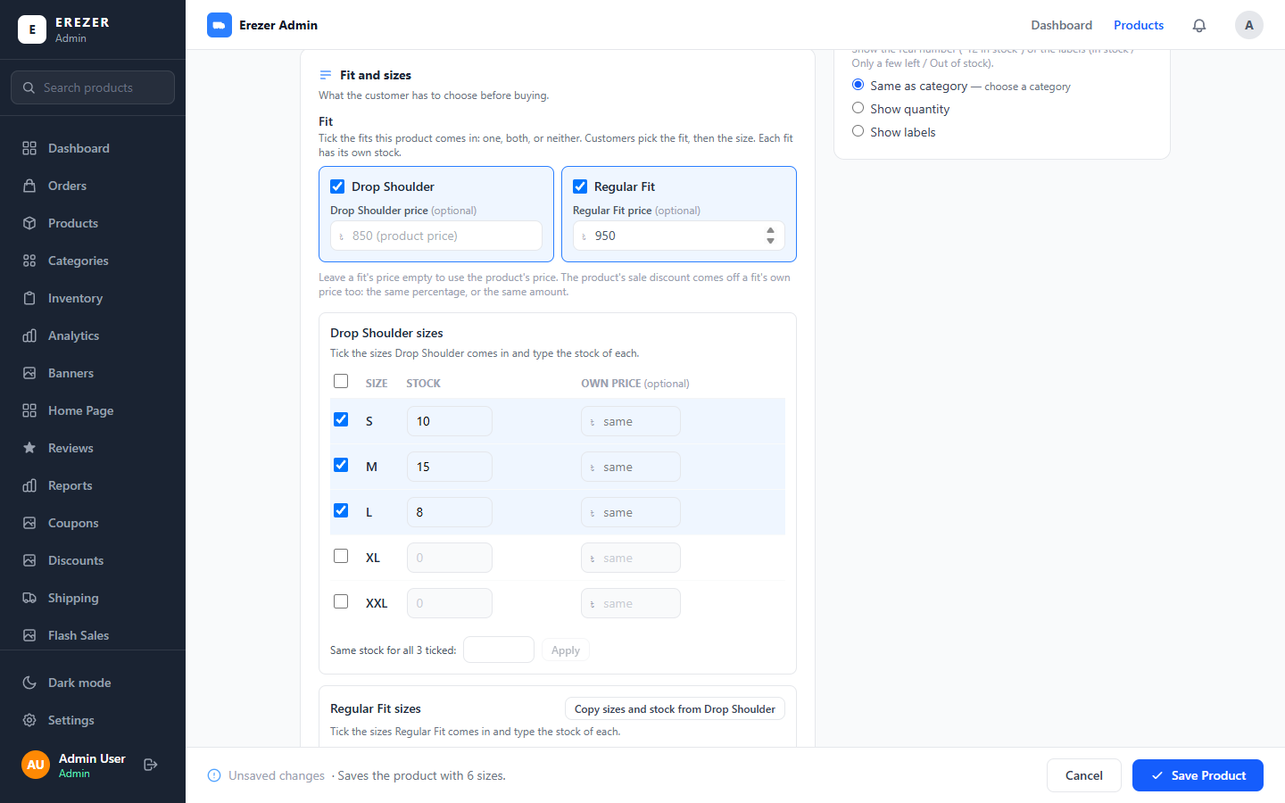
Picture: Fit and sizes on the Add product page: both fits ticked, Regular Fit at its own price.
- Drop Shoulder is already ticked on a new product. Tick Regular Fit as well if the product comes in both. Untick both for a product with no fit.
- If a fit costs a different amount, type it in that fit's price box. Leave the box empty to use the product's Base Price.
- Under Drop Shoulder sizes, tick the sizes and type the stock of each.
- Under Regular Fit sizes, do the same. When you tick the second fit it starts with the same sizes ticked, so you only type the stock. Copy sizes and stock from Drop Shoulder copies the numbers too.
What you sell | What to tick
A T-shirt or hoodie in one cut | One fit, and its sizes
The same design in both cuts | Both fits, and the sizes of each
A product with sizes but no fit | Untick both fits, then tick the sizes
A cap, a bag (no fit, no sizes) | Untick both fits and leave the sizes unticked

Remember A fit must have at least one size ticked. If Drop Shoulder is ticked and no size is, the product is not saved and a message tells you what to do.

- The product's stock is the total of every fit and size. Drop Shoulder S 10, M 15, L 8 and Regular Fit S 6, M 4, L 12 gives 55.
- The discount comes off every fit, the way you typed it: "10% off" takes 10% off each fit's price, "৳100 off" takes ৳100 off each.
- A size can still have its own price in the last column; that wins over the fit's price for that one size.
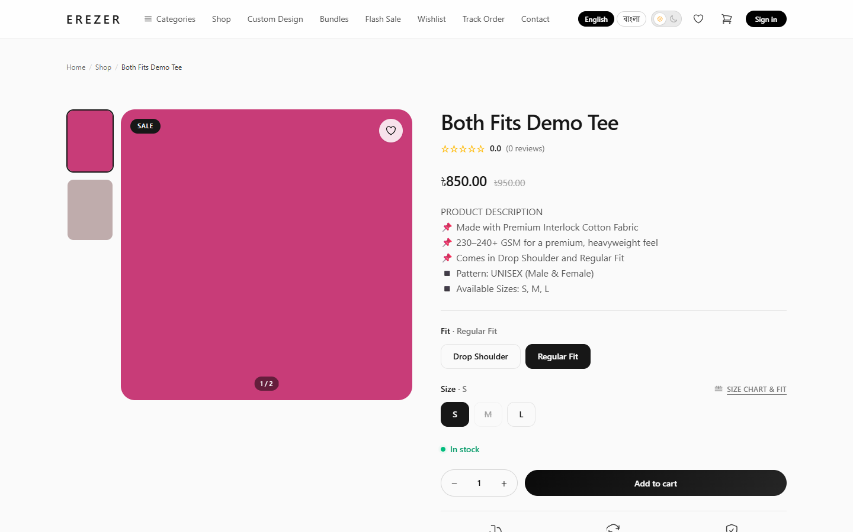
Picture: What the customer sees: the fit buttons above the size buttons. A size with no stock is crossed out.

Colours and other options
A product can also come in colours, or in any other choice you need, such as Sleeve: Short or Long. These are called options. In the shop the customer picks each option, then the fit, then the size. Every combination is a variant with its own stock and, if you want, its own price.
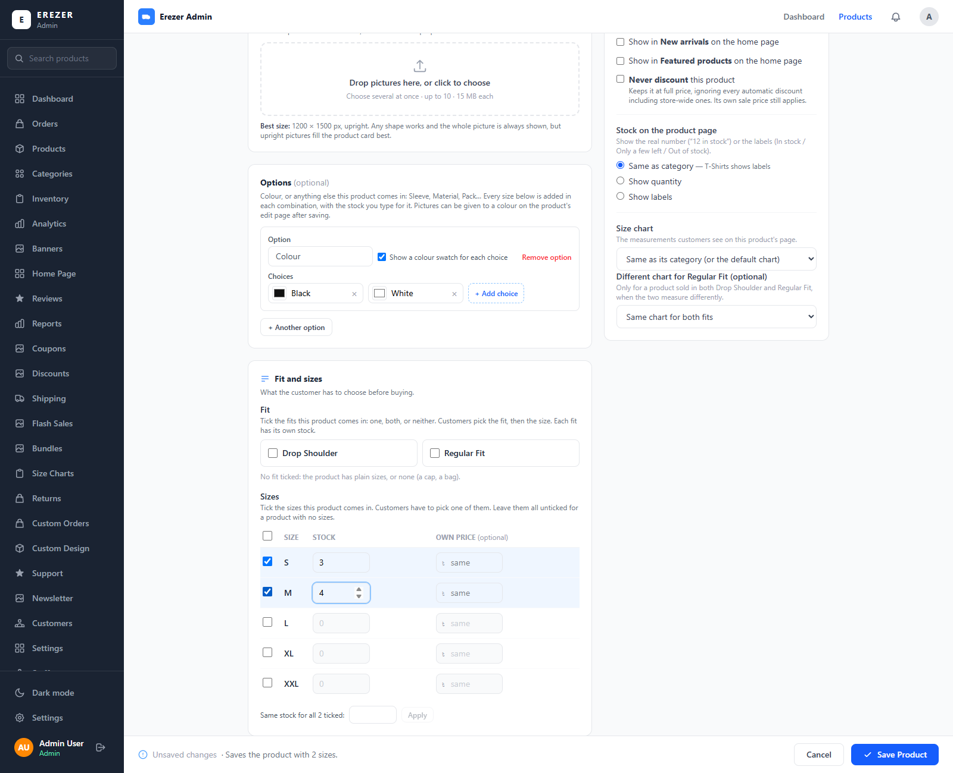
Picture: The Options box on the Add product page, with Colour added.
- In the Options box, press + Colour. It starts with Black and White. Rename them, click the small coloured square to pick each colour, and press + Add choice for more colours.
- For a choice that is not a colour, press + Another option, type its name (for example Sleeve) and its choices.
- Tick the fits and sizes and type the stock, as usual. Every colour gets those sizes with that stock. You can change each one afterwards on the edit page.
- Save the product.
- Two colours, both fits and three sizes make 2 × 2 × 3 = 12 variants, each with its own stock.
- A product can have up to 500 variants.
- In the shop, a colour shows as a round swatch. A choice with nothing in stock is greyed out.
- A product with no options works exactly as before: the customer picks the fit and the size.

Adding several products at once
Use this when a batch of products shares the same name, description, price, fits and sizes, and only the pictures and codes differ, for example ten designs of the same T-shirt.
- On the Products page, press Add several products.
- In Shared by all, choose the Category and type the Name, Description and Price. These are used for every product in the batch.
- Tick any options you want: New arrivals, Featured, Never discount, and how stock is shown.
- Under Fit, tick the fits and give a fit its own price if it has one, exactly as on Add product. Then tick the sizes of each fit and type the stock. Every product in the batch gets these fits, sizes and stock.
- If the products come in colours, add them under Options: every product in the batch gets the same choices. You can also choose a Size chart for the whole batch, and a different one on any row.
- In Products, set photos per product (for example 4), then drop all the photos into the box. They are dealt out in name order: the first 4 photos make product 1, the next 4 make product 2, and so on. The first photo of each is its main picture.
- Check the rows. Each row is one product. You can change its name, its code or give it its own price.
- Press Save products at the bottom. All of them are saved together.
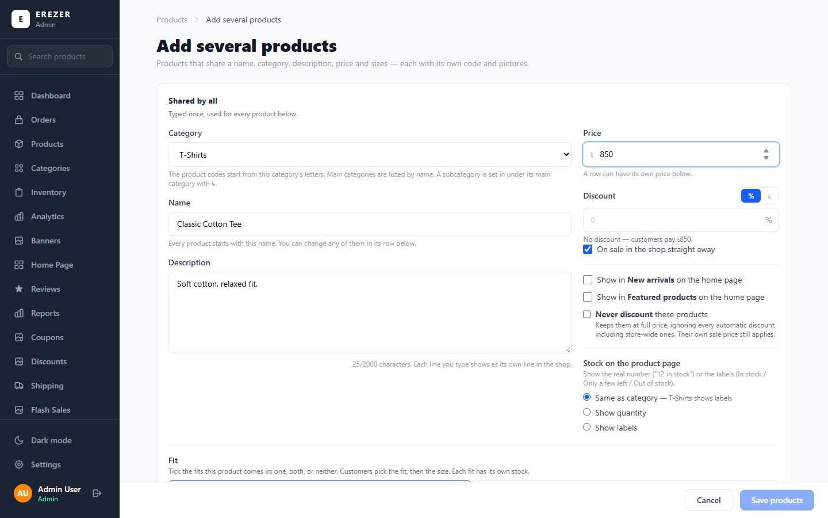
Picture: Add several products: the top part is typed once and shared by every product.
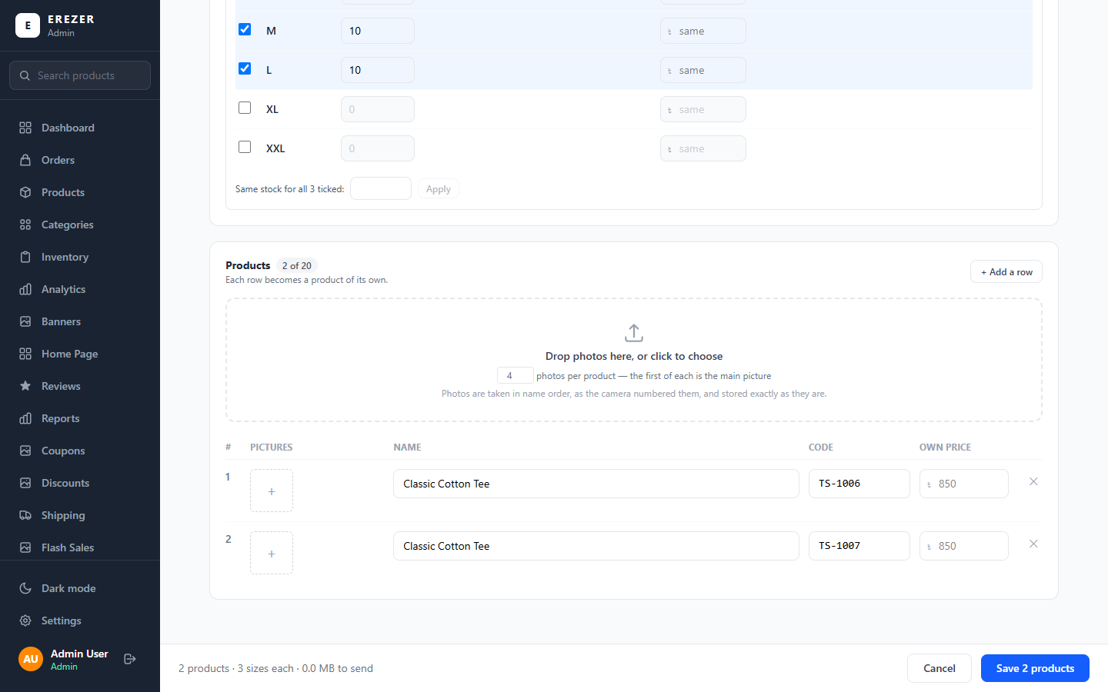
Picture: Each row at the bottom becomes one product, with its own code.
- One batch can have up to 20 products, with up to 10 photos each.
- Codes are filled in for you from the category's letters (TS-1005, TS-1006…). A code you type yourself gets an orange border and is left alone.
- If anything is wrong in one row, nothing is saved and the message tells you which row to fix.

Changing a product
- On the Products page, press the pencil on the product's row.
- Change what you need: name, description, price, discount, category or options.
- Under Variants, the Options box sets the colours and other choices, and the Fit box sets the fits (both are explained below). The list under them shows every variant: you can add a size, change a variant's stock or price, or delete one.
- Under Product images you can upload more photos, remove one, and choose which colour each photo is Shown for.
- Press Update Product at the bottom.

Changing the colours and options of an existing product
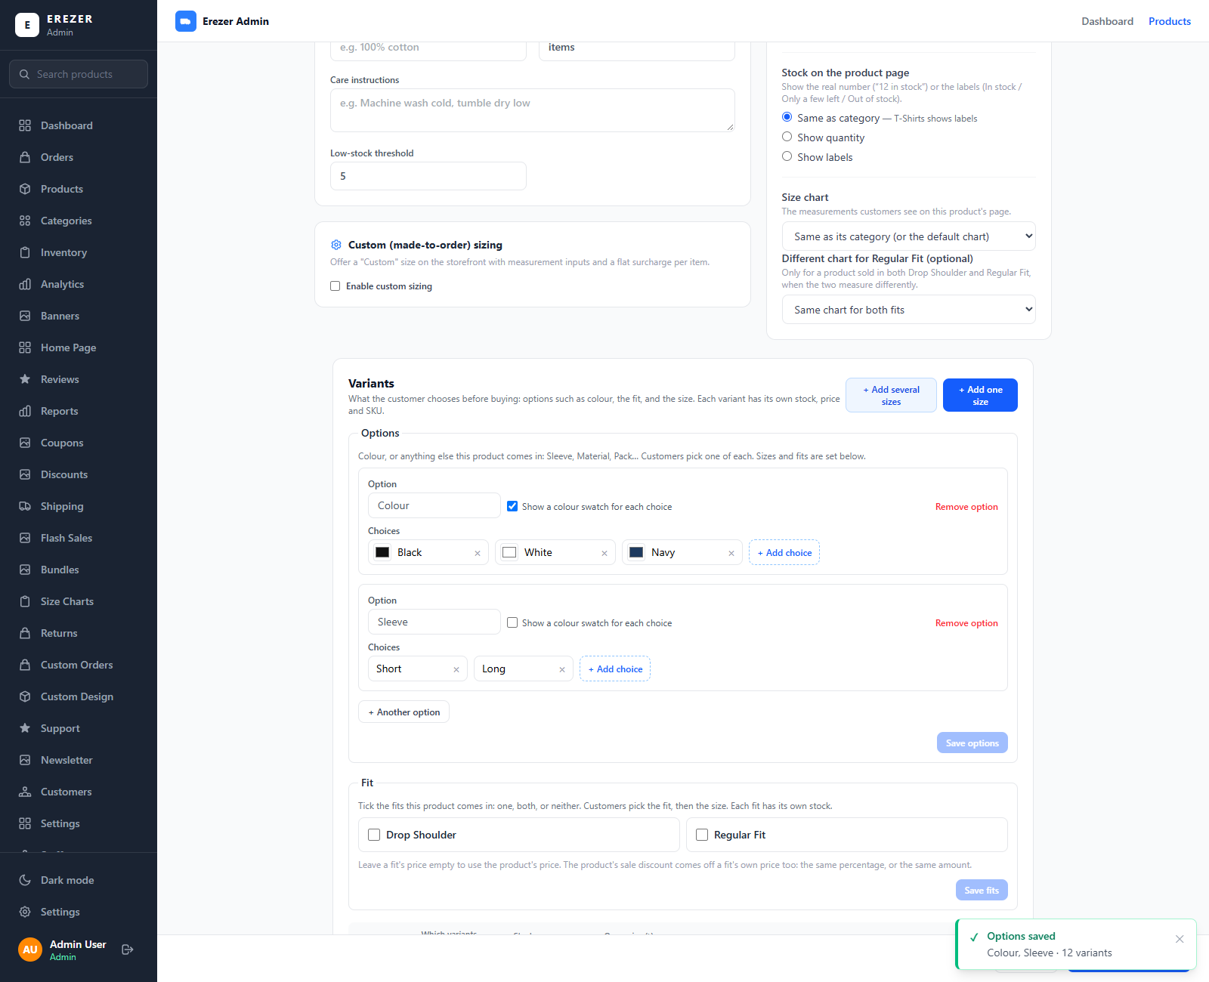
Picture: A product in colours. Each row of the list is one variant, with its own stock.
- Open the product and scroll to Variants.
- In the Options box, add an option, add or rename a choice, or remove one. The line under the box tells you what will happen before you save, for example "2 combinations × 2 sizes = 4 variants".
- Press Save options.
What you do | What happens
Add the first option to a product that already had sizes | Its sizes become the first choice (for example Black) and keep their stock. The other choices start with 0 stock.
Add a choice | It gets every size the product has, with 0 stock. Type the stock in the list below.
Remove a choice | Its variants and their stock are removed. The panel asks you first.
Delete one variant from the list | Only that combination goes. A link, Put back deleted variants, brings it back with 0 stock.

- Set for many, above the list, sets the stock or the price of many variants in one go: choose which ones (for example Colour: White), type the number and apply.
- Photos for a colour: under Product images, each photo has Shown for. Choose a colour, and the photo is shown when the customer picks that colour. Photos left on Every choice show for every colour.
Be careful Removing a choice removes its stock and cannot be undone. Orders already placed keep the colour they were ordered in.

Changing the fits of an existing product
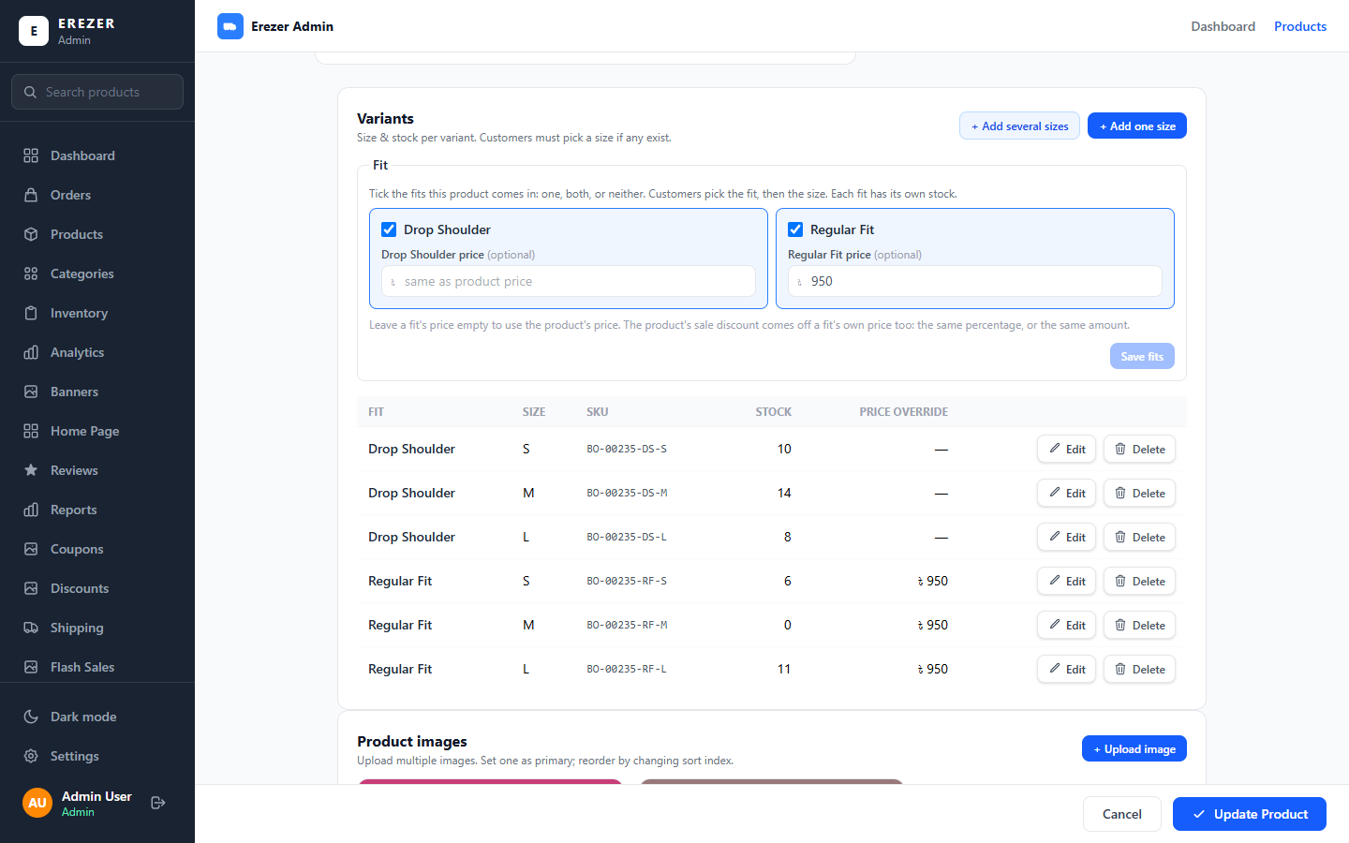
Picture: The Fit box on the Edit product page, with the sizes of both fits listed under it.
- Open the product and scroll to Variants.
- In the Fit box, tick or untick Drop Shoulder and Regular Fit, and type a fit's price if it has its own.
- Press Save fits.
What you do | What happens
Tick a fit on a product that had plain sizes | Its sizes become that fit and keep their stock.
Tick a second fit | It gets every size the product has, with 0 stock. Type the stock in the list or in Inventory.
Untick a fit | That fit and its stock are removed. The panel asks you first.
Untick both | The product goes back to plain sizes; the stock of the two fits is added together.

Be careful Removing a fit removes its stock and cannot be undone. Existing products have no fit until you set one.

Setting fits on many products at once
On the Products page, press Fits. Tick the fits, then choose Chosen products (and tick products in the list) or A category, and apply. Products with no sizes are left alone, and prices are not changed.
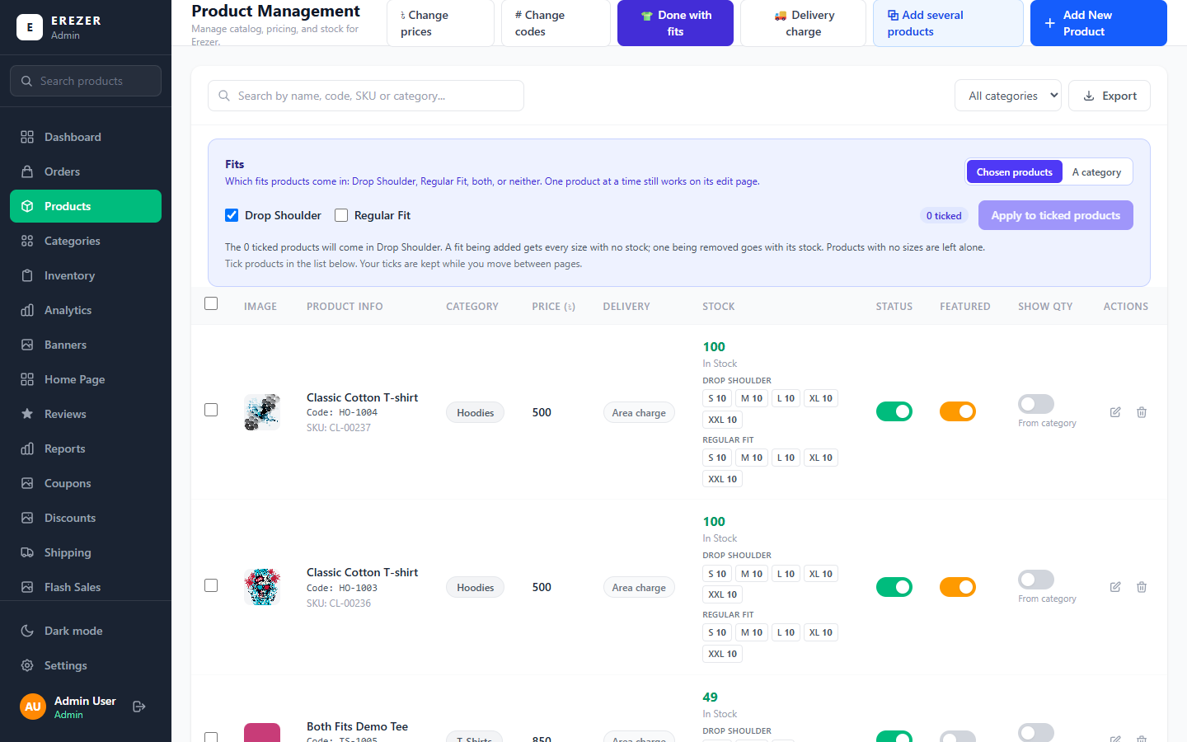
Picture: The Fits panel on the Products page.

Changing many products at once
Tick the box at the start of each product's row. A blue bar appears above the list with everything you can do to the ticked products.
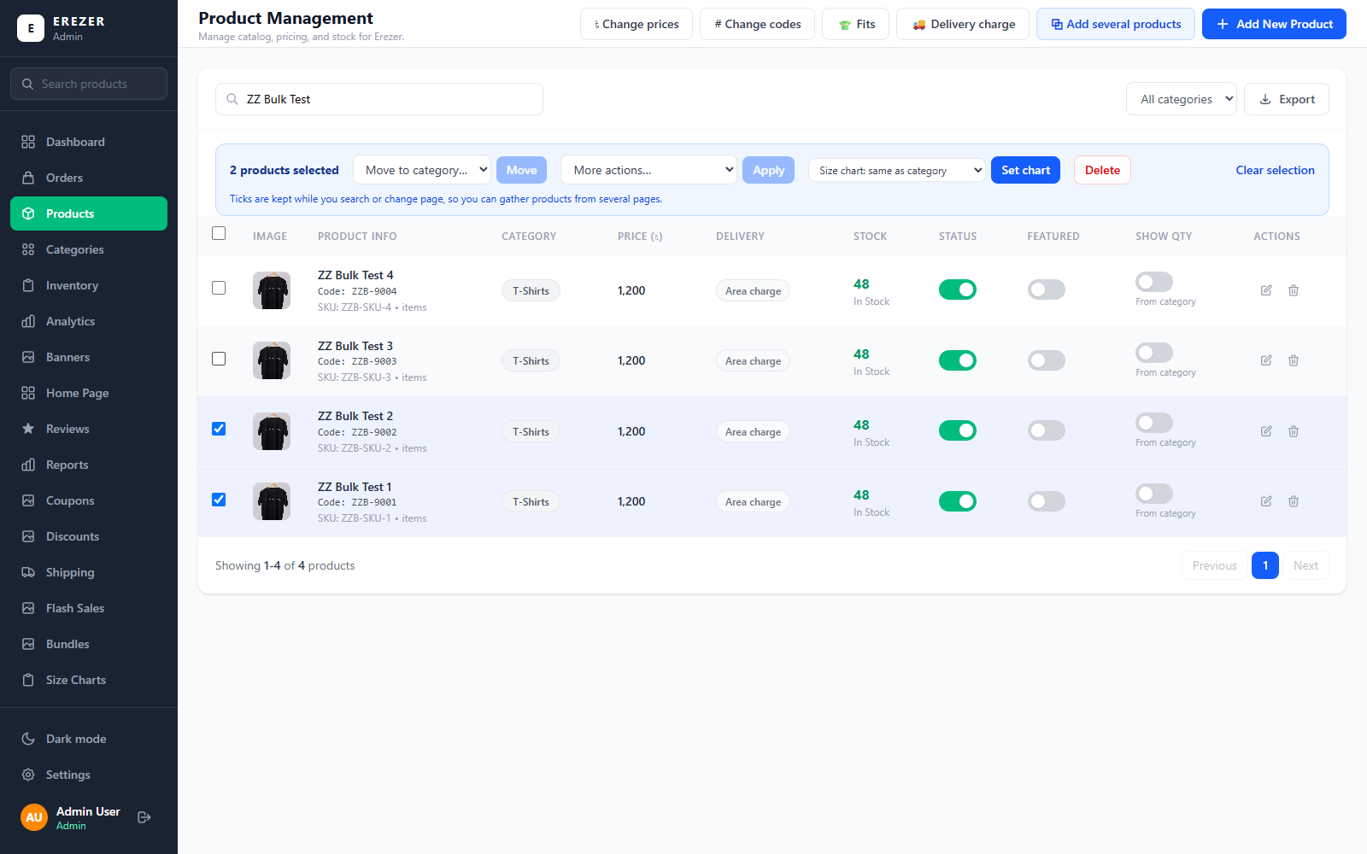
Picture: The blue bar that appears when products are ticked.
In the bar | What it does
Move to category, then Move | Moves the products to another category. Their product codes stay the same.
More actions, then Apply | Show in the shop or hide from it; feature on the home page or stop featuring; mark as new arrival or remove from new arrivals; never discount or allow discounts again; show the stock quantity or labels only.
Size chart, then Set chart | Gives all of them the same size chart, or puts them back on their category's chart.
Delete | Deletes them. The panel asks you first.
Clear selection | Unticks everything.

- Your ticks are kept while you search or change page, so you can gather products from several pages.
- You can change up to 500 products at a time.
- Before anything changes, the panel tells you how many products it will change and asks you to confirm.
- For prices, codes, fits and delivery charges, use the buttons at the top of the page, described next.

Changing many prices at once
- On the Products page, press Change prices.
- Choose the Category. Choosing a main category includes its subcategories.
- Choose what to do with the price: set every price, raise or lower by an amount, or raise or lower by a percentage.
- Choose what to do with the sale discount: keep it, set one for all, or remove it.
- Press Show preview. You see every product with its old and new price. Nothing has changed yet.
- Untick any product you want to leave out, then apply.

Changing many product codes at once
Press Change codes on the Products page, choose a category, and choose either the same code for every product or a prefix with numbers (EP-001, EP-002…). Press Show preview first; nothing is saved until you apply. This works on one category at a time and does not reach into its subcategories.

Setting the delivery charge for products
Normally the delivery charge comes from the customer's area (Inside Dhaka or Outside Dhaka; see Part 8). The Delivery charge button on the Products page lets you set a special charge for chosen products, a whole category, or the whole shop, for example free delivery on one product. A product showing Area charge in the list uses the normal area price.

Choosing which products come first in the shop (Shop Order)
The Shop Order page decides which products customers see first on the Shop page and on every category page. You rank the products that matter; all the others follow them by themselves.
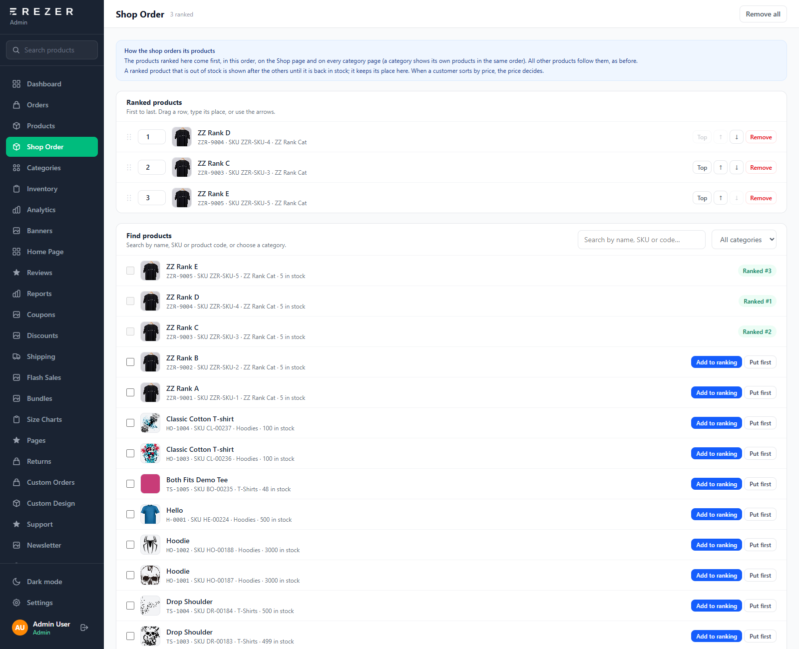
Picture: Shop Order. The ranking is at the top; the list below finds products to add to it.
- Open Shop Order in the menu.
- In Find products, search by name, SKU or product code, or choose a category.
- Press Add to ranking to put a product at the end of the ranking, or Put first to put it at the top. Tick several products to add them together.
- In Ranked products, change a product's place: drag its row, type a number in its place box, or use Top, ↑ and ↓.
- Remove takes one product out of the ranking. Remove all clears the ranking.
- Every change is saved at once. A green "Shop order saved" message confirms it.
- Ranked products come first, in your order. A category page shows its own products in the same order.
- A ranked product that is out of stock is shown after the others until it is back in stock. It keeps its place in your list and returns by itself.
- When a customer sorts the shop by price, the price decides.
- Up to 500 products can be ranked. The home page sections are not affected.

5. Categories and subcategories
A main category is a group that stands on its own, such as Hoodies. A subcategory sits inside another category, such as Zip Hoodies inside Hoodies. A subcategory can have subcategories of its own, as deep as you need: Hoodies › Zip Hoodies › Kids.
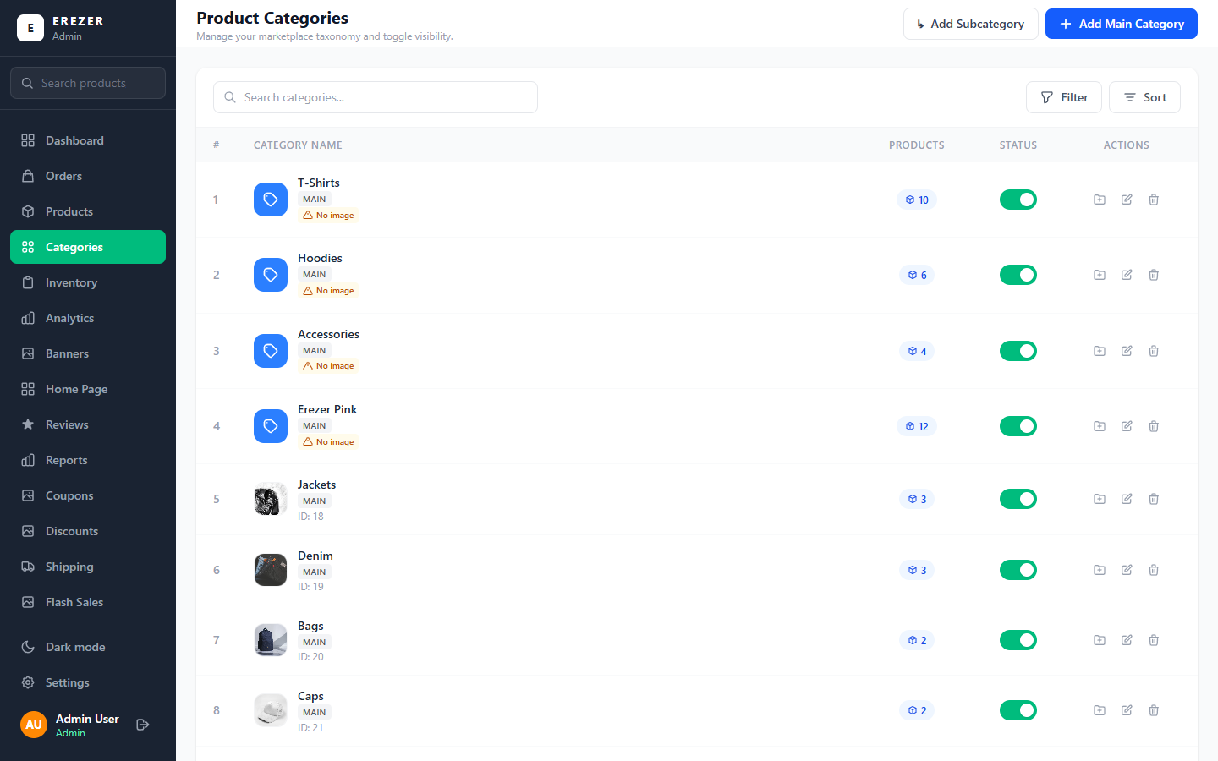
Picture: The Categories page. Main categories are marked MAIN; subcategories appear set in under them.

What customers see
- Opening Hoodies in the shop shows every hoodie, including those in its subcategories, with buttons to narrow down to one subcategory.
- Each subcategory also has its own page.
- The home page and the "Shop by category" tiles show main categories only.

Adding a main category
- On the Categories page, press Add Main Category.
- Leave "What are you adding?" on Main category.
- Type the Category Name and upload a Category Image.
- Leave Active on so customers can see it.
- Press Save Category.

Adding a subcategory
- On the Categories page, press Add Subcategory. (Or press the small folder button on the main category's row; that fills in step 2 for you.)
- Under Inside which category? choose the category it belongs in. This can be a main category or another subcategory.
- Type the name, upload an image if you have one, and press Save Subcategory.
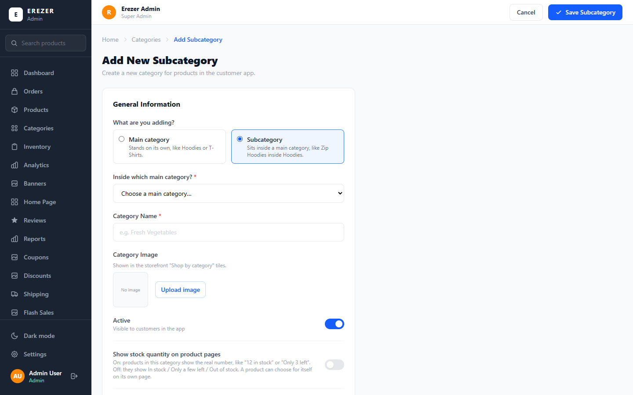
Picture: Adding a subcategory. The first question is which kind you are adding.

How to recognise them in lists
Wherever you choose a category (adding a product, bulk stock, price changes), main categories are listed by name and each subcategory is set in under its main category with an arrow:
Hoodies
↳ Hoodies › Pullover Hoodies
↳ Hoodies › Zip Hoodies
T-Shirts

Rules worth knowing
- A subcategory follows the category above it for delivery charge, discounts, size chart and how stock is shown, unless you set something different on the subcategory.
- Product codes use each category's own letters: a product in Zip Hoodies gets ZH-1001, not HO-1001.
- A category that has subcategories cannot be deleted until its subcategories are deleted or moved.
- A subcategory can have subcategories of its own. A category's page shows the products of everything under it, together.

Other switches on a category
Switch | What it does
Active | Off hides the category from customers.
Show as a section on the home page | Gives a main category its own row of products on the home page.
Show stock quantity on product pages | On: products in it show the real number. Off: they show a label.
Never discount this category | Keeps every product in it at full price during automatic discounts.
Size chart for this category | The size table shown on every product in it and in its subcategories, unless a product has its own chart (see Part 9).

6. Inventory (stock)
The Inventory page is where you keep stock numbers right. The three boxes at the top show how many products are critically low, out of stock, or waiting to be re-ordered.
Remember For a product sold in sizes, stock is kept per size, and for a product that comes in fits, per fit and size: Drop Shoulder M and Regular Fit M are counted separately. The product's own number is always the total: 5 sizes with 600 each shows 3000. When a customer buys a size, that size goes down and so does the total.

Updating one product
- Find the product with the search box.
- Press Update Stock (or Restock) on its row.
- For a product with sizes: type the stock of each size. For a product with fits there is a row of boxes under each fit. The total adds up on screen as you type.
- For a product without sizes: choose Set to exact value, Add to current stock or Remove from stock, and type the quantity.
- You can also set the Low Stock Threshold: the number at which the product is marked Low Stock.
- Press Confirm.
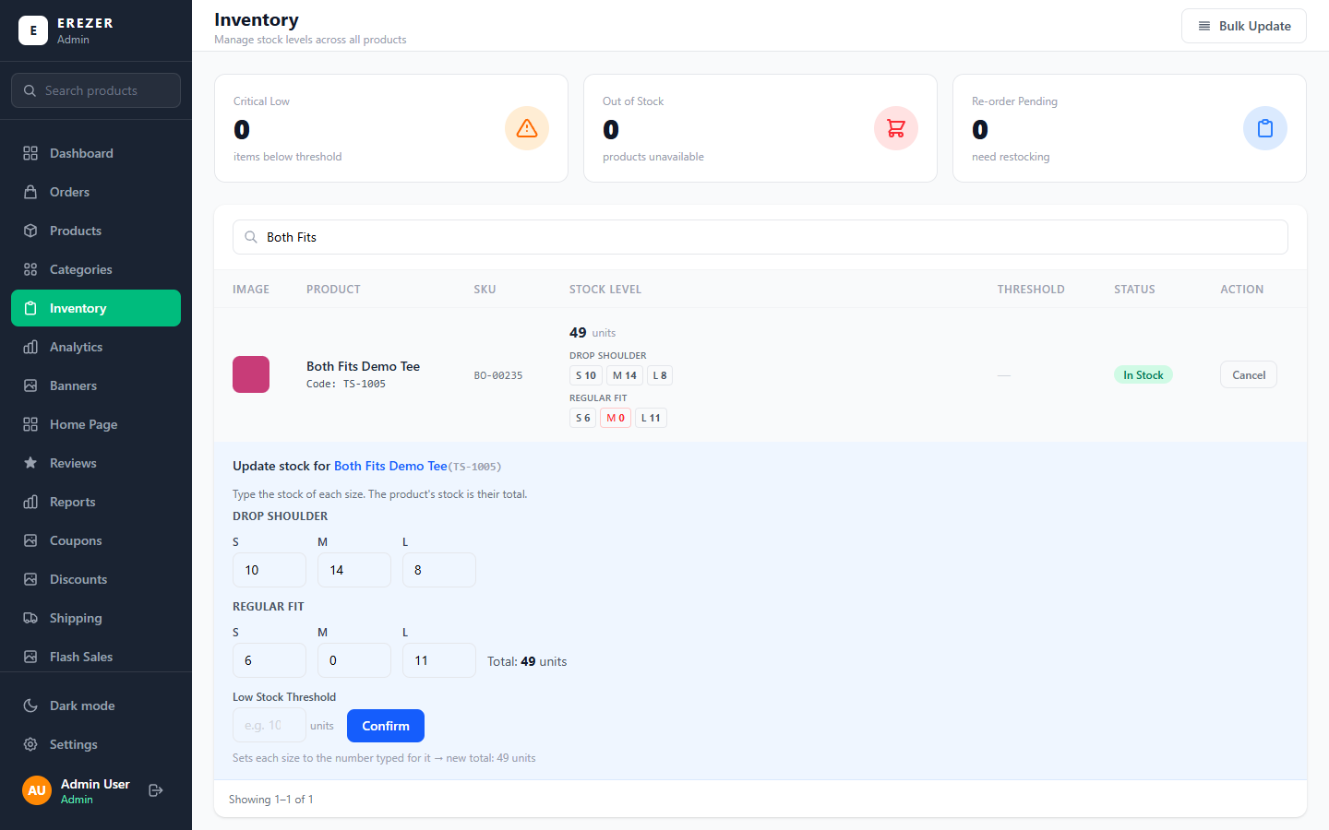
Picture: Updating a product with both fits: a box for each size under each fit, with the total beside them.

Updating many products at once (Bulk Update)
Press Bulk Update at the top right. A panel opens with three tabs.
Tab | How it works
Chosen products | Tick products in the list and type the new stock for each. A product with sizes gets a box per size, grouped under each fit. Your ticks are kept while you move between pages.
By category | Choose a category, what to do (add, remove, or set to exact value) and the quantity. Choosing a main category also changes the products in its subcategories.
All products | The same, for every product in the shop.

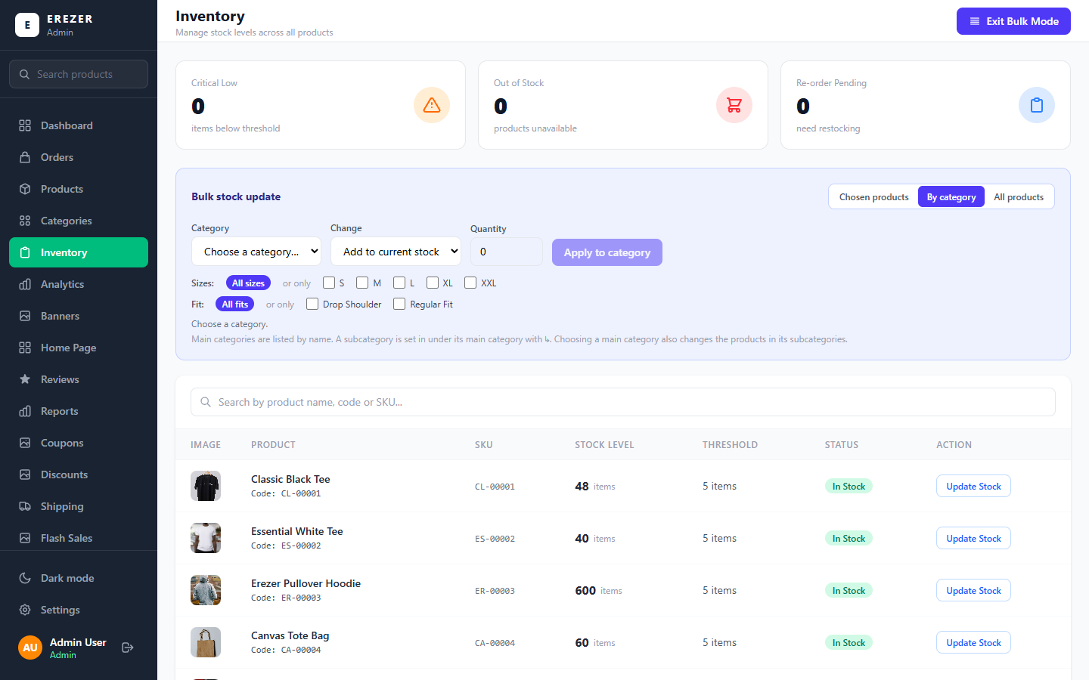
Picture: Bulk stock update, on the "By category" tab.

The Sizes line and the Fit line
- All sizes: the quantity is applied to every size of each product.
- Only some sizes: tick S, M, L, XL or XXL to change just those. Other sizes, and products without those sizes, are left alone.
- All fits: both fits are changed.
- Only one fit: tick Drop Shoulder or Regular Fit to change just that fit. Products that do not come in it are left alone.
- You can combine them: "only Regular Fit, only size M".
Be careful The quantity is per size. "Set to exact value 600" puts 600 on each size, so a product with 5 sizes will show 3000. "Set" replaces the old stock; it does not add to it. Read the grey line under the form before you apply: it says exactly what will happen.

Tip When you finish, press Exit Bulk Mode.

7. Offers and prices
There are five ways to lower a price. Pick the one that matches what you want to do.
Tool | Use it for | Where
Sale price on a product | One product is cheaper for a while | Products → edit the product → Discount
Discount | An automatic reduction on the whole shop, a category or a product; customers do nothing | Discounts
Coupon | A promo code the customer types in the cart | Coupons
Flash sale | A short sale on chosen products with a start and end time | Flash Sales
Bundle | A deal for buying several products together: a fixed price, Buy X Get Y free, or a quantity discount | Bundles

Coupons (promo codes)
- Open Coupons and press + New coupon.
- Type the code customers will enter (for example WELCOME10).
- Choose the type and value: a percentage or a fixed amount.
- If you want, set a minimum order amount, a limit on how many times it can be used, and the dates it is valid.
- Save.
- The Active switch on each row turns one coupon on or off.
- The big switch at the top turns the whole promo code box in the shop on or off. When it is off, no coupon works.
- Used / Limit shows how many times a code has been used.
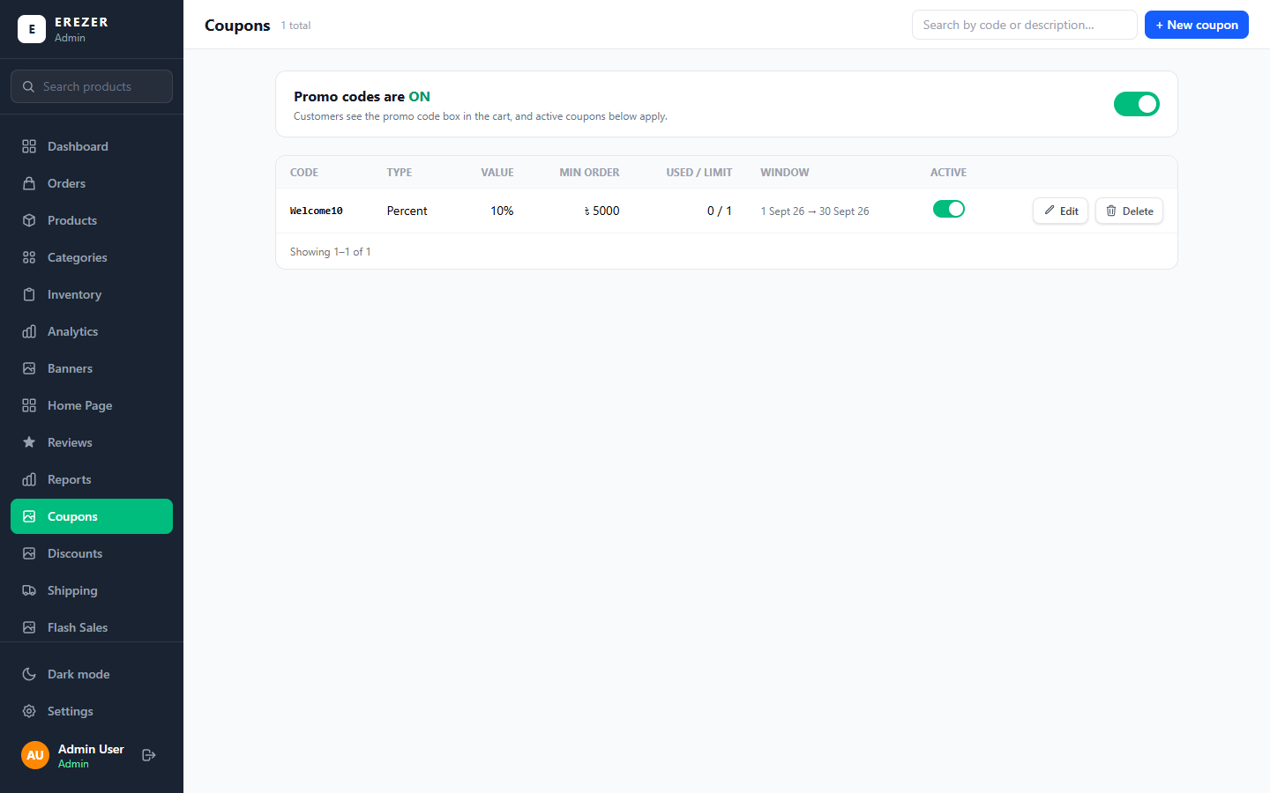
Picture: The Coupons page.

Discounts (automatic)
A discount applies by itself at checkout and shows on product cards; the customer does not type anything. Press + New discount and choose what it covers: the whole store, one category, or one product.
- A discount on a main category also covers its subcategories.
- Stackable discounts can combine with other stackable ones. A non-stackable discount applies alone.
- When two discounts overlap and do not stack, the one with the higher priority number wins.
- The switch at the top turns all automatic discounts off at once. Sale prices, coupons, flash sales and bundles keep working.
- To protect a product or category from every automatic discount, turn on Never discount on that product or category.

Flash sales
Open Flash Sales and press + New flash sale. Give it a name, the offer, the products it covers, and the start and end time. Several flash sales can run at once. The home page shows the one marked Featured; if none is featured, it shows the active one that ends soonest.

Bundles
A bundle rewards customers for buying several products together. Open Bundles, press + New bundle, choose the kind of offer, and tick the products customers can pick from.
Kind of offer | Example | What you type
Fixed-price bundle | Any 3 for ৳999 | How many items, and the one price for all of them.
Buy X Get Y free | Buy 2 Get 1 Free | How many to buy, how many are free, and the price the customer pays for all of them.
Quantity discount | Buy 2 save 10%, buy 3 save 15% | The steps: a quantity and its percentage off. Up to 6 steps.

- The customer builds the bundle on the bundle's own page in the shop, choosing the colour, fit and size of each item.
- A coupon cannot be used on top of a bundle.
- The home page shows the bundle marked Featured.
Tip On the shop's product cards, a product on sale shows the price the customer pays with the regular price crossed out beside it.

Remember A product's own discount applies to every fit. If a product costs ৳850 with Regular Fit at ৳950, "৳100 off" sells them at ৳750 and ৳850, and "10% off" at ৳765 and ৳855.

8. Shipping
The Shipping page controls what customers pay for delivery. The line at the top, Right now, tells you in one sentence what is currently happening.
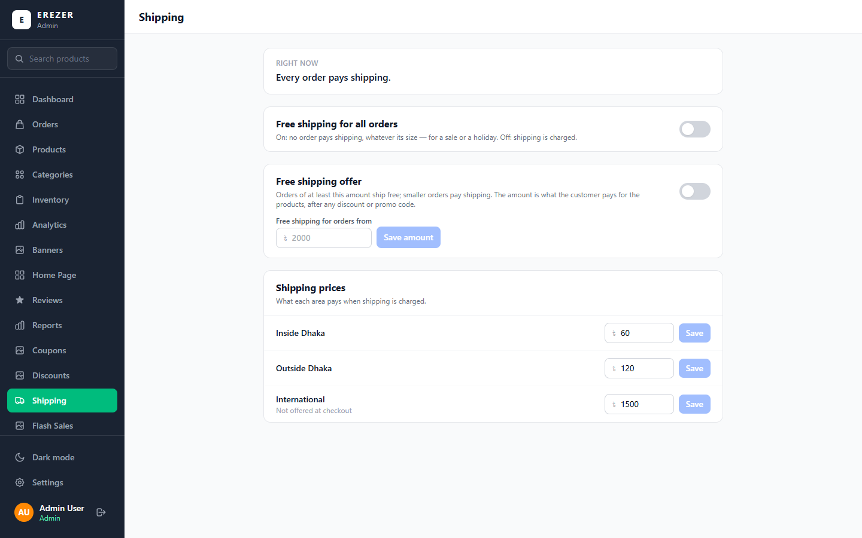
Picture: The Shipping page.
Setting | What it does
Free shipping for all orders | A switch. On: nobody pays shipping, whatever the order size. Use it for a sale or a holiday.
Free shipping for orders from ৳… | Orders of at least this amount ship free; smaller orders pay. The amount is what the customer pays for products after discounts.
Shipping prices | What each area pays: Inside Dhaka and Outside Dhaka. Type the price and press Save beside it.

Remember Each price has its own Save button. Changing a number without pressing Save beside it does nothing.

A product or a category can also have its own delivery charge, which wins over the area price. That is set from the Delivery charge button on the Products page (see Part 4).

9. How the shop looks

Banners
Banners are the big pictures on the home page. Each banner belongs to a spot: the big picture at the top, the two tall pictures, the four small tiles, and the "design your own" photo.
- Open Banners.
- To change one, press Edit on it. To add one, press Add banner and choose its spot.
- Upload the picture, type the heading and the button text, and choose where the button leads (the shop, or a category).
- Save.
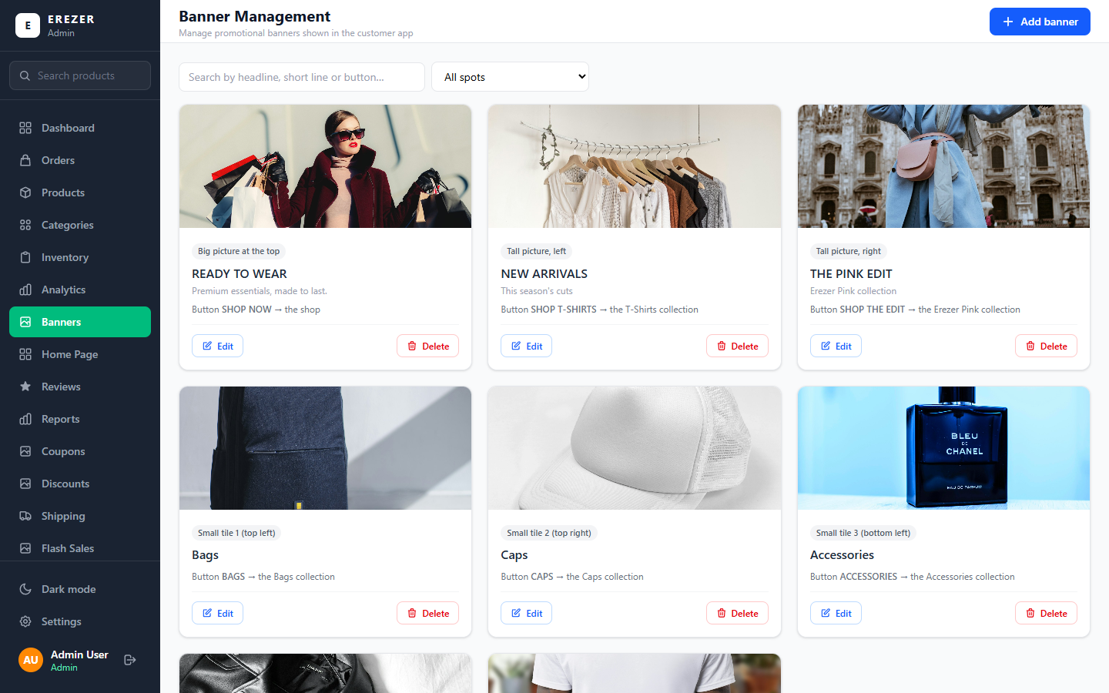
Picture: The Banners page, grouped by spot.
- Picture for phones (optional, on the big top banner): an upright picture that phones show instead of the wide one. Its best size is 1080 × 1600 px. Without it, phones show the whole wide picture across the top of the screen.
- Under every picture upload, the panel tells you the best size for that picture. Following it keeps pictures sharp and uncut.

Home Page
The Home Page page decides which sections the shop's home page shows and in what order.
- Open Home Page.
- Use the switch on a section to show or hide it.
- Use the ↑ and ↓ arrows to move a section up or down.
- Press Save layout. Nothing changes in the shop until you do.
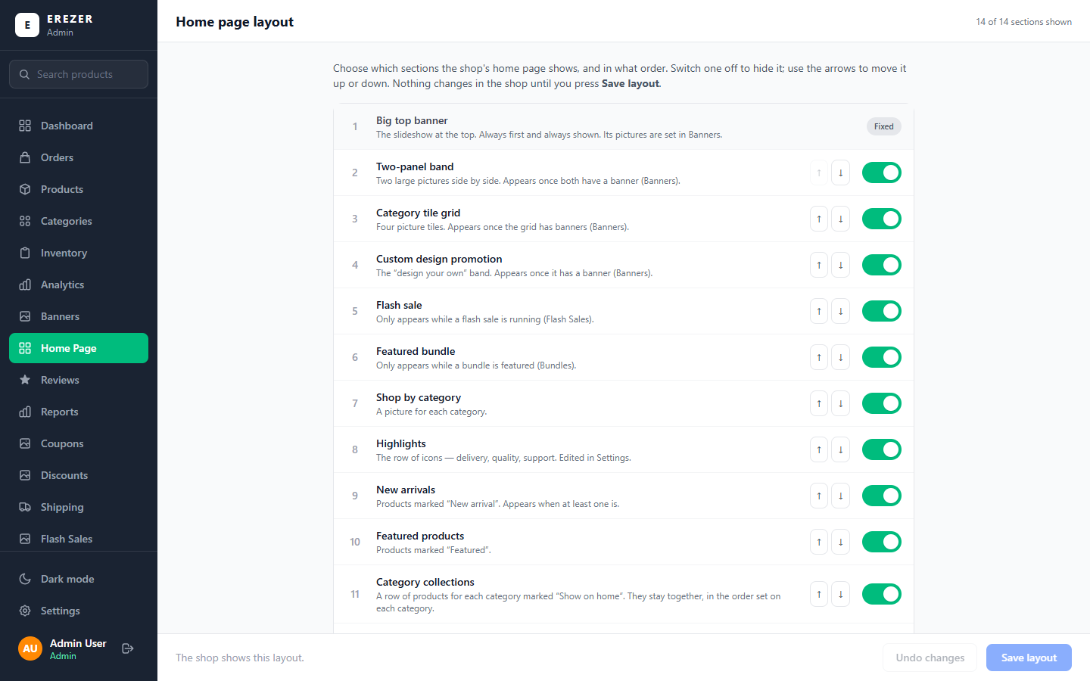
Picture: The Home Page layout. The big top banner is always first.
- Some sections only appear when they have something to show: Flash sale appears only while a flash sale is running, Featured bundle only while a bundle is featured.
- The button at the bottom puts everything back to the original order with every section on.

Settings (shop information)
Settings holds the text and information that appears around the shop. Change what you need and press Save changes at the top.
Section | What it changes
Return & exchange policy | The policy text shown on every product page.
Days a customer has to request a return | How many days after delivery a customer can ask for a return. After that the shop no longer offers it. The policy text is separate: change it too if you change the number.
Customer support | The phone, email and hours shown to customers.
Payment methods | Which options customers can choose at checkout: Cash on Delivery, bKash, Card. At least one must stay on.
Size chart | Size charts now have their own page: Size Charts in the menu (see below).
Brand story | The "Our story" section on the home page: heading, text, photos and social media links. You can add several social links.
About page | The title, introduction and sections of the About page.
Home highlights | The row of icons on the home page (delivery, quality, support).
Footer | The bottom of every shop page: brand name, links, outlets, copyright line.
Footer → Our outlets | Your shop locations: picture, name, address, phone and a Google Maps link. A customer who presses a location is taken to it on Google Maps. To get the link, open the shop in Google Maps, press Share and copy it. Left empty, the map is searched for the name and address.
Trust strip | The phrases in the scrolling text strip on the home page.
Meta Pixel | Connects the shop to Facebook and Instagram ads. Leave this to the shop owner.

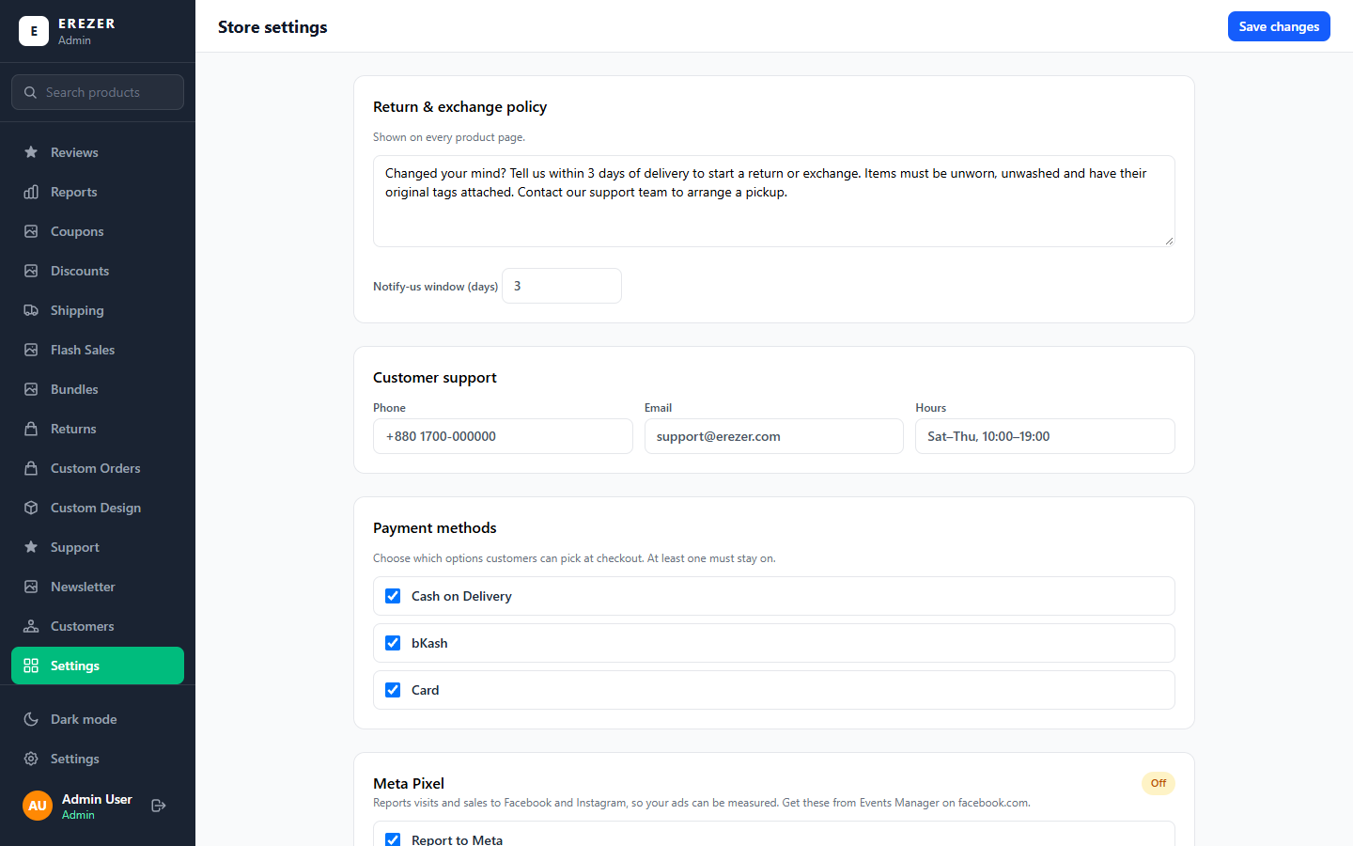
Picture: The Settings page. It is long; scroll down to see every section.

Size Charts
The Size Charts page keeps every size table the shop uses. You can have as many as you need, for example General, Drop Shoulder, Regular Fit and Kids. One of them is the default.
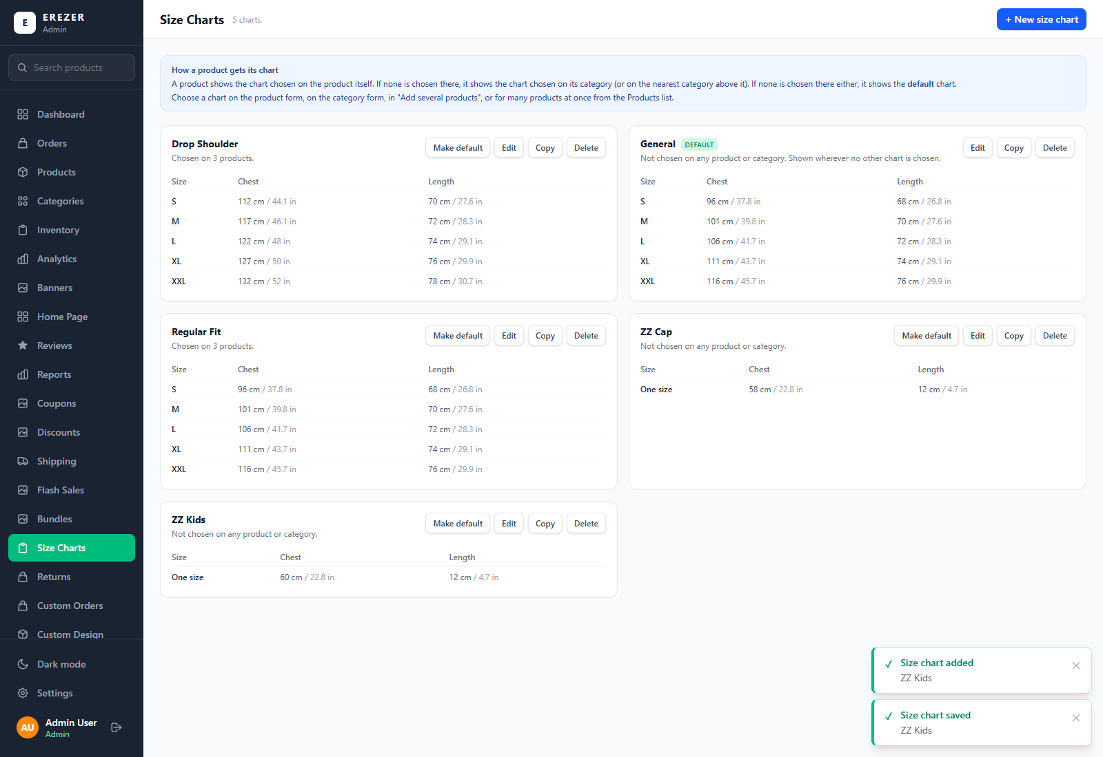
Picture: The Size Charts page.
- Open Size Charts and press + New size chart. To change one, press Edit on it; Copy starts a new chart from an existing one.
- Type the Name of the chart. Only staff see the name; customers see the measurements.
- + Column adds something you measure (Chest, Length, Sleeve). + Size row adds a size (S, M, L). Each box takes both cm and inches.
- Save.
- Make default chooses the chart shown when nothing else is chosen.
- Delete removes a chart. Products and categories that used it go back to the chart of their category, or to the default. The panel tells you how many, and asks first.

Which chart a product shows
The shop looks in this order and shows the first chart it finds:
- The chart chosen on the product itself (Size chart, on the product form).
- The chart chosen on its category (Size chart for this category), or on the nearest category above it.
- The default chart.
- A product in both fits can show a different chart for Regular Fit: choose it under Different chart for Regular Fit (optional) on the product form. The chart's title in the shop names the fit.
- To give many products the same chart, tick them on the Products page and use the size chart box in the blue bar.

Pages
The Pages page holds pages of your own words, such as Our Mission, Our Values and Shipping & Returns. You write the words; the shop lays them out.
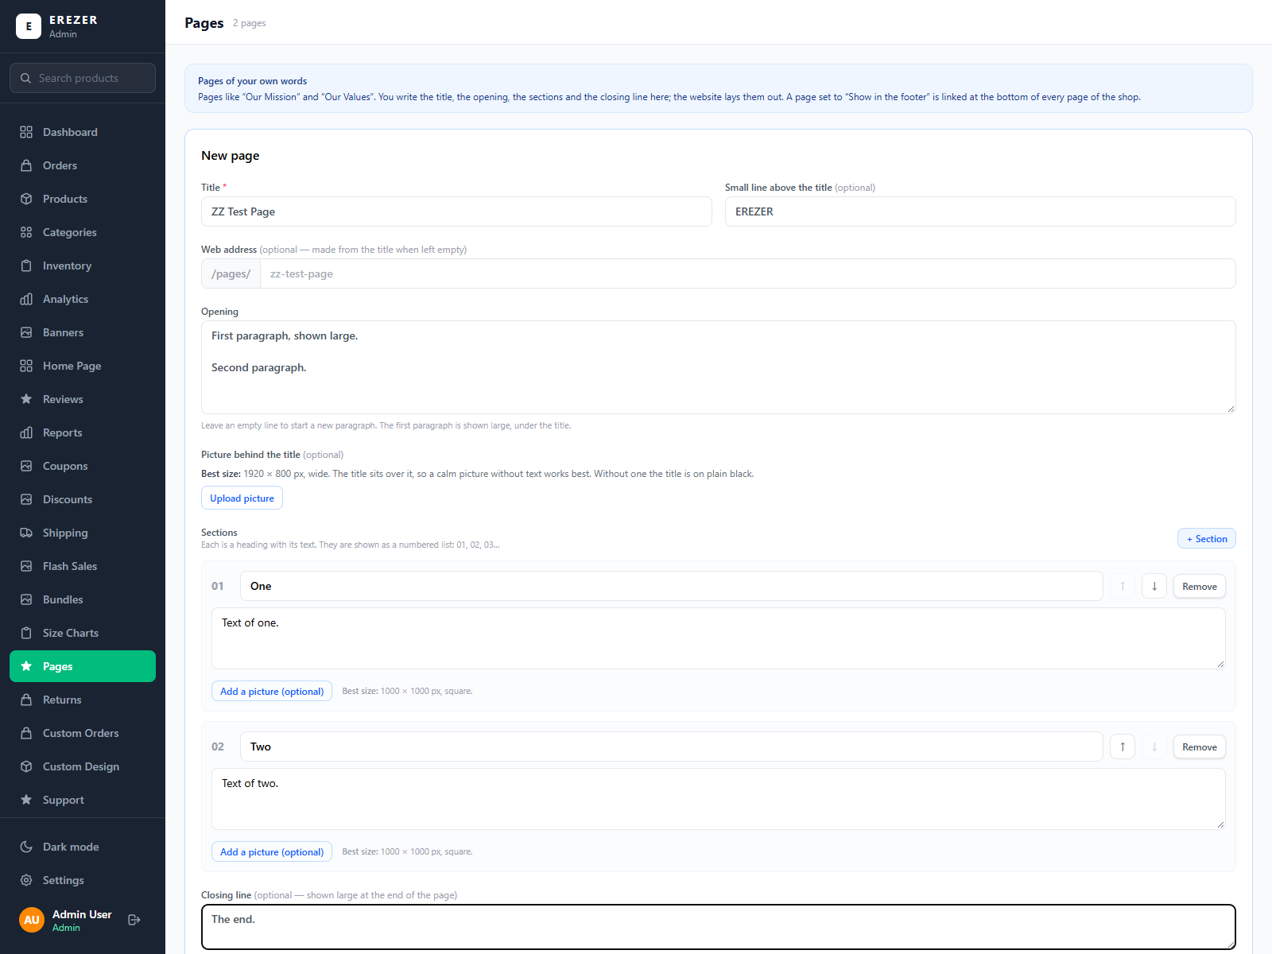
Picture: Editing a page.
- Open Pages and open the page you want to change, or press + New page.
- Type the title and the opening text. Leave an empty line to start a new paragraph. The first paragraph is shown large, under the title.
- If you want, add a picture behind the title. Its best size is 1920 × 800 px, wide; a calm picture without text works best.
- Under Sections, press + Section for each heading with its text. The shop shows them as a numbered list: 01, 02, 03.
- If you want, add a closing line and a button at the end of the page.
- Tick Show in the footer if the page should be linked at the bottom of every shop page.
- Save.
Remember Read your Shipping & Returns page once in a while. It should say the same as your delivery prices (Part 8) and your return days (Settings).

10. Customers and messages

Returns
When a customer asks to return an item, the request appears on the Returns page. Click a request to read it and see its photos, then move it through its steps: Requested → Approved (or Rejected) → Picked up → Refunded. Use the filter at the top to see only one step.
A customer can ask for a return for a set number of days after delivery. You choose that number in Settings, under Days a customer has to request a return.

Custom Orders
Customers can design their own garment in the shop. Each request appears on Custom Orders. Click one to see the design, the garment and colour, the customer's details and the original files they uploaded. Move it through New → In review → Quoted → Confirmed → Closed as you deal with it. History shows closed requests.

Custom Design
This page controls what customers can design on. Garments lists the items offered (for example T-Shirt and Hoodie) with their colours; press + New garment to add one. Logo library holds ready-made logos customers can place on their design.

Support
Messages sent through the shop's contact form (the Help Center) arrive in Support. Use the filter to see New, Read or Resolved messages. You can answer a message without leaving the panel.
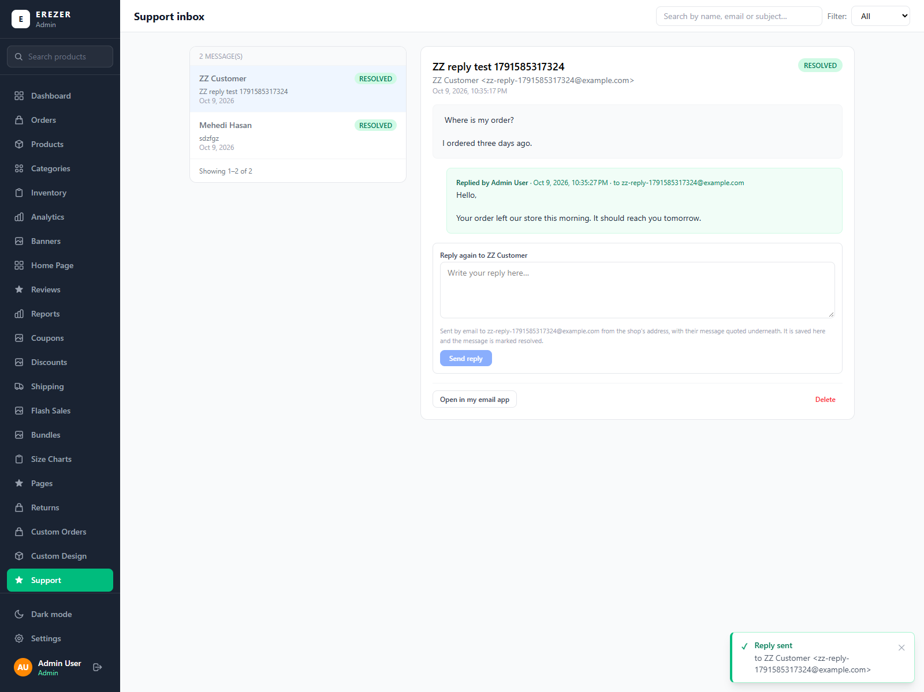
Picture: A customer's message with the reply sent from the panel under it.
- Click a message to read it.
- Type your answer in the reply box under it. The box shows the email address your answer will go to.
- Press Send reply.
- The customer receives an email from the shop with your answer, and their own message under it.
- Your reply is kept under the message, with who sent it and when, and the message becomes Resolved. You can send more than one reply.
- If the customer answers that email, their answer goes to the shop's support email address (the one in Settings, under Customer support), not into the panel.
- Open in my email app is still there if you prefer to answer from your own email. Replies sent that way are not kept in the panel.
Remember If the email could not be sent, the panel says so in red and does not save the reply, so a message is never marked answered when the customer received nothing. Wait a moment and send it again.

Reviews
Reviews shows customer reviews product by product. Choose a product on the left to see its reviews on the right. You can remove a review that is abusive or fake.

Customers
Customers lists everyone who has bought from the shop, ranked by how much they have spent. For each customer you see the number of orders, total spent, average order, and first and last order dates.

Newsletter
Newsletter lists the email addresses of people who signed up in the shop, and whether each is still subscribed.

11. Sales numbers
Page | What it shows
Dashboard | A quick look: revenue today, this week and this month, pending orders, the revenue trend, stock alerts and best sellers.
Analytics | Order health (delivery rate, cancellation rate, average order value), orders by status, revenue by payment method, top categories and best sellers. Choose the period at the top.
Reports | A full business report for a day, week, month, year or fiscal year, compared with the period before. You can Export CSV (opens in Excel) or Print.

Remember Revenue numbers leave out cancelled and returned orders. In the reports, a subcategory's sales are counted under its main category.

12. Staff
There are two kinds of staff login.
Role | What they can do
Admin | Everything.
Moderator | Only what has been ticked for them.

Adding a staff member
- Open Staff and press + Add moderator.
- Type their full name, a username and their email.
- Type a temporary password, or press Generate to get one.
- Choose the role.
- For a moderator, tick what they are allowed to do. The permissions are grouped by area: Orders, Products, Inventory and so on.
- Save, then give them their username and temporary password.
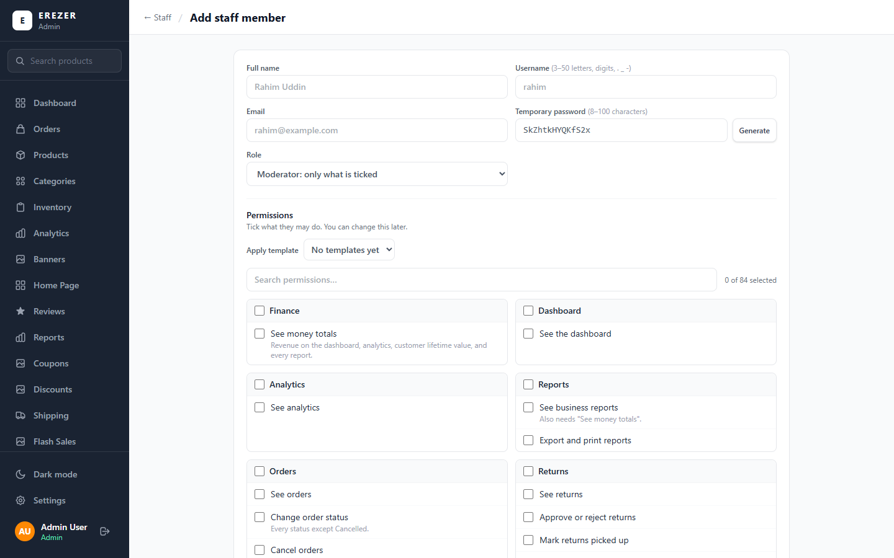
Picture: Adding a staff member and ticking what they may do.

Managing existing staff
- Permissions: change what a moderator may do.
- Reset password: give them a new temporary password if they forget theirs.
- Deactivate: stop a login from working without deleting it. Use this when someone leaves.
Tip Give each person only what their job needs. Someone who packs orders needs "See orders" and "Change order status", not prices or staff.

Activity log
Activity log is the record of who did what and when: every change to products, stock, orders, prices and settings. Filter it by person, by area or by date. Use it when you need to find out who changed something.

13. Problems and answers
Problem | What to do
A page looks wrong, or a button does nothing | Reload the page with Ctrl + F5. This loads the newest version of the panel.
I changed something but the shop still shows the old version | Check that you pressed the save button. Then reload the shop page.
A menu item in this guide is missing for me | Your login does not have permission for it. Ask the shop owner.
A product shows "Out of stock" but I have stock | Open Inventory, find the product and check its sizes. If every size is 0, type the real numbers and confirm.
I set stock to 600 and the list shows 3000 | That is correct for a product with 5 sizes: 600 on each size. The sizes are listed under the total.
The product is in the list but customers cannot see it | Its Status switch is off, or its category is not Active. Switch it on.
A coupon does not work | Check that the coupon is Active, its dates include today, the order is above its minimum, its limit is not used up, and the big "Promo codes" switch is on.
A product is not getting the store discount | Check whether "Never discount" is on for the product or its category.
I cannot delete a category | It has subcategories. Delete or move them first.
The bulk upload saved nothing | One row had a problem. Read the red message: it names the row. Fix it and save again.
The product will not save: "Tick the sizes Drop Shoulder comes in" | A fit is ticked but none of its sizes are. Tick its sizes, or untick the fit if the product has no fit.
Both fits show the same size chart in the shop | Open the product and choose a chart under Different chart for Regular Fit. Without one, both fits show the product's chart.
The discount shows on one fit only | Open the product and press Update Product once. Discounts saved before fits existed are then applied to every fit.
I added a fit and it shows "sold out" | A fit that is added to an existing product starts with 0 stock. Type its stock in Inventory.
I added a colour and it shows as sold out | A colour that is added to an existing product starts with 0 stock. Type its stock in the product's Variants list or on the Inventory page.
A colour shows the wrong photos | Open the product. Under Product images, set Shown for on each photo to its colour. Photos left on Every choice show for all colours.
A product I ranked is not first in the shop | It is out of stock, so it is shown after the others until it is back. Or the customer sorted the shop by price. Check its place on the Shop Order page.
The product shows the wrong size chart | Size Charts explains the order: the product's own chart, then its category's, then the default. Open the product and check its Size chart box.
My reply to a customer was not sent | The panel shows a red message and does not save the reply. Check your internet connection and send it again. If it keeps failing, tell the shop owner.
A photo looks small on the product card | The shop shows the whole photo. Use tall (portrait) photos of the same shape for all products so they fill the cards.
I cannot log in | Check the username and password for typing mistakes. If it still fails, ask an admin to press Reset password for you on the Staff page.

14. Quick finder
Find what you want to do in the left column; the right column tells you where to go.
I want to… | Go to
Accept a new order | Orders → open the order → Update Status
Print an invoice | Orders → open the order → Print Invoice
Cancel an order | Orders → open the order → Next status: Cancelled
Add one product | Products → Add New Product
Add many similar products | Products → Add several products
Change a product's price or photos | Products → pencil on its row
Sell a product in Drop Shoulder and Regular Fit | Products → Add New Product → Fit and sizes
Add or remove a fit on a product | Products → pencil → Variants → Fit → Save fits
Set the fit of many products | Products → Fits
Sell a product in colours | Products → Add New Product → Options → + Colour
Add a colour to a product | Products → pencil → Variants → Options → Save options
Show a photo for one colour only | Products → pencil → Product images → Shown for
Choose a product's size chart | Products → pencil → Size chart
Add or change a size chart | Size Charts
Hide a product for now | Products → switch Status off
Put a product on the home page | Products → switch Featured on
Change many prices at once | Products → Change prices
Move, hide, feature or delete many products | Products → tick the products → the blue bar
Choose which products come first in the shop | Shop Order
Add a category or subcategory | Categories → Add Main Category / Add Subcategory
Update stock for one product | Inventory → Update Stock
Update stock for many products | Inventory → Bulk Update
Update the stock of one fit only | Inventory → Bulk Update → Fit line
Create a promo code | Coupons → + New coupon
Run a store-wide discount | Discounts → + New discount
Run a flash sale | Flash Sales → + New flash sale
Make a bundle offer | Bundles → + New bundle
Change the delivery price | Shipping → Shipping prices
Give free shipping | Shipping → Free shipping switch or amount
Change a home page picture | Banners → Edit
Give the top banner a picture for phones | Banners → Edit → Picture for phones
Hide or reorder a home page section | Home Page → switches and arrows → Save layout
Change the return policy or contact details | Settings
Change how many days customers have to return | Settings → Days a customer has to request a return
Change Our Mission, Our Values or Shipping & Returns | Pages
Add a shop location's Google Maps link | Settings → Footer → Our outlets
Turn a payment method on or off | Settings → Payment methods
Handle a return request | Returns
Answer a custom design request | Custom Orders
Read and answer a customer message | Support → open the message → Send reply
Remove a bad review | Reviews
See this month's sales | Reports → Monthly
Add a staff member | Staff → + Add moderator
See who changed something | Activity log

